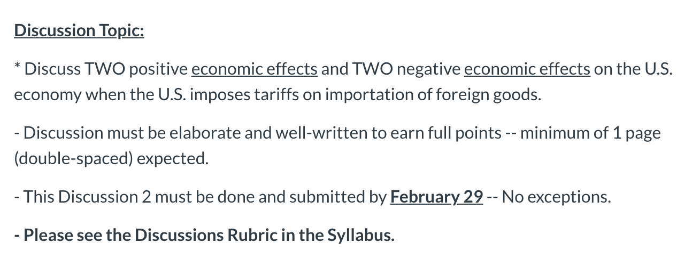

notes: Include sources, Rubric attached
TOPICS can be chosen from the internet

MODULE 5

Trade Protectionism

n Trade protectionism is the practice whereby countries restrict trade flows with each other.
- Trade protection is done by using various measures to restrict the flow of imports or exports of goods and services across countries.

- The instruments of trade protection are the measures that are used to impose trade restriction. Examples of such instruments include import duties, and export duties.

- Import duties and export duties are types of taxes that are imposed on imports and exports — they are also called trade Tariffs.

- Through trade protectionism, countries are able to “protect” producers in their own economies, from competition from producers of other countries whose imported goods might compete with the products of the domestic producers.

- It is important to fully understand why countries practice trade protectionism.

Why Countries Practice Trade Protection and Trade Restriction

- Trade Protectionism arises as countries
adopt various trade restrictionist measures to protect their domestic markets, on behalf of domestic producers, against foreign competitors.

- But the question is, why do countries practice trade protection and trade restriction, despite all the benefits that come from international trade?

Reasons for Trade Protectionism

-- The following are the main reasons for why countries restrict trade, despite the massive benefits of international trade:

(1) Optimum tariff argument A country suffering from “trade volume imbalance” (unfavourable Balance of Trade)
could try to correct the situation by imposing an "OPTIMUM TARIFF" rate to restrict the volume of imports.

-- A country would face the problem of a Trade Deficit if/when the country’s volume of imports exceed its volume of exports. This would mean that the country is facing the problem of buying more goods and services from the rest of the world, than it is selling to the rest of the world.
-- Therefore, if/when a country has a deficit in its trade balance, it could try to remove that deficit by restricting imports.
-- The country could then impose a Tariff rate on imports, that would reduce the volume of imports coming into the country. Such a tariff rate is termed an Optimum Tariff rate.

(2) Infant industry argument
Infant industries are newly established firms and businesses in a country.

-- When new firms are businesses are created, they begin to operate at relatively higher costs of production than well established firms that are already operating in foreign countries.
-- Therefore there is a need to "protect" the country’s newly established (infant) industries that are not yet able to compete with mature foreign industries.
-- The reason for infant industries inability to compete is because a new firm tends to operate at a higher (sub-optimal) level of its Average Cost curve; but over time, as the firm gradually expands its production level, unit costs of production go down.
-- But during the “infant” stages of operation, the firm may need “protection” from the fierce free market competition with mature foreign firms and competitors.

- The graph is used to illustrate the Infant Industry situation.

- Please refer to the graph provided in this Module, entitled: “Infant Industry Production Cost”.

- The symbols used in this graphical illustration are:
AC = Average Cost of production
Q = Quantity of output produced

- The production cost situation facing a typical newly created “infant” firm, is represented by the AC (Average Cost) curve.

- The shape of the AC curve indicates that the Average Cost of production falls as production is increased, and continues to fall up to the point “c”; and then begins to rise later after the point “c”.

- The point “a” is the initial output Q₁, with unit cost (Average Cost) of production AC₁, showing the initial operation point of a typical infant firm.

- However, over time as the firm matures, it is able to expand its output to point “b”, at output level Q₂ and unit cost AC₂.

- The point “c” indicates the OPTIMAL operation point showing the lowest (minimum) unit cost of production AC3, at higher output level Q₃. This is the most efficient operation point — the production level that yields the lowest unit cost of output.

— The Infant Industry argument for protectionism is that the newly created firm, which typically operates at point “a”, needs to be “protected” from more established foreign firms that would be operating at point ”b” or even at point “c”.

(3) Anti-dumping measure
“Dumping” is the act of foreign producers selling their products cheaper in the foreign market than their own domestic market.
- Dumping of products enable foreign firms to capture and take over the markets of a country simply by being more competitive (selling products cheaper) in the country’s domestic market.

- Moreover, dumping of products tend to often involve inferior-quality products, designed by foreign firms to create greater export intensity for themselves, while enabling them to enforce higher import penetration into the domestic economy of that country.

- Therefore, as a measure to counter this “dumping” practice of foreign firms, the country would impose tariffs on the importation of the “dumping” products.

Forms of Trade Protection

* There are several forms of trade protectionist measures that a country can apply to restrict International Trade.
-- The various forms of trade protectionist measures are known as the Instruments of of trade production. The main ones are:

- Trade embargo: A country simply bans the importation or exportation of the products of another country, or countries, into its own economy.
-- Trade embargo is usually adopted for political reasons, known as economic sanctions.

- Trade quotas: Trade quota is a fixed (restricted) volume of the imports or exports, that may be traded with another country, or countries.
— A trade quota is a pre-determined set of quantities of goods and services that are permitted to be traded between the country and another country, or countries.

- Trade tariff: Tariff is the most commonly used protectionist measure. -- The tariff is a tax imposed on goods imported into the country.
-- Tariffs raise the prices of imported products, thereby giving a competitive edge to domestic producers.

- Subsidies: Subsidies are direct grants or tax concessions, given to domestic producers.
— Subsidies help lower costs of production for domestic firms, to help them compete with international competitors.

- Countervailing duties: these are special tariffs imposed on the importation of foreign products whose production were subsidized by their own home governments. -- These are designed to protect the importing country's domestic producers from the supposedly "unfair competition" of the foreign producers.
-- It may however be seen as retaliatory action, and might trigger retaliation from foreign trading partners.

- Non-tariff barriers: These are other forms of import restrictions such as: * product standard and quality regulations,
- environmental regulations,
- health and safety standards, * labor standards (e.g. the "child labor” controversy.

